**Coursera Capstone Project – “The Battle of Neighborhoods”**

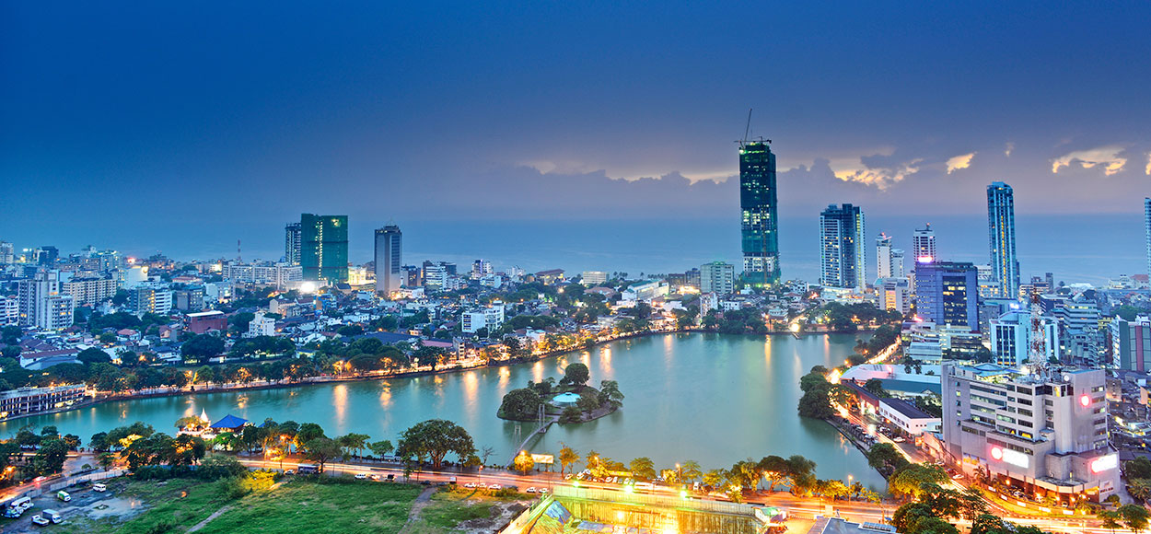

# Opening a new Shopping Mall in Colombo, Sri Lanka

**By Zufar Haseeb**

**July 2019**

### **Introduction**

##### For many Shoppers, visiting a shopping mall is a one stop solution for relaxation and enjoyment during weekends and other holidays. Visitors can carry out their weekly grocery shopping, watch a movie at the cinema, visit a play area with their kids, dine with the family at a restaurant and perform many other activities. For retailers, shopping malls are a prime location to attract large amount of crowd to promote their goods and services. Subsequent to the 30 year long civil war in Sri Lanka, the property developers in the country are also taking advantage of this trend to build many shopping malls around Colombo and its suburbs and many are currently being built. A new shopping mall may generate consistent revenue for property developers while the location of the shopping mall being the key determinant of consistent revenue through the success of the shopping mall.

### **Business Problem**

##### Until the Colombo City Center was opened in August 2018, neither the residents of Colombo nor the increasing number of tourists arriving in Sri Lanka did not have a international level shopping mall in Colombo that would provide all activities under one roof with the same quality as it is seen in other developed countries. Objective of this project is to analyze and select the best location in Colombo, Sri Lanka to open a new shopping mall. Using data science methodologies such as clustering, this project aims to provide suggestions for locations in Colombo city for a new shopping mall to be built.

### **Target Audience**

* Property Developers
* Foreign Investors
* Travel Publishers
* Financing Institutions, etc.

### **Data**

##### We will require following data to solve this problem

* List of neighborhoods in Colombo. This defines the scope of the project which will be confined to the city of Colombo, the capital city of the country of Sri Lanka in South Asia
* Latitude and Longitude coordinates of above neighborhoods in order to plot the maps and obtain venue data
* Venue data, particularly data of shopping malls. This can be used to perform clustering of neighborhoods.

### **Sources of Data**

* The Wikipedia page (<https://en.wikipedia.org/wiki/Category:Suburbs_of_Colombo>) contains a list of neighborhoods in Colombo with a total of 65 neighborhoods. We will be using web scraping techniques to extract data from the Wikipedia page with the help of Python and beautifulsoup packages. Then we will get the geographical coordinates of the above neighborhoods using Python's Geocoder package.
* Foursquare API to get venue data for above neighborhoods. Foursquare has one of the largest data base of over 100 million places and is used by over 150,000 developers across the world. Foursquare API will provide many categories of venue data and we will be focusing on shopping mall category in order for us to solve the problem that has been put forward.